**EXPERIMENT NO: 08**

**EXPERIMENT TITLE:** Prepare Test cases

**Objective:**

1.To write Test cases.

2.To understand test format.

3. To understand the working of JIRA tool

**DATE TURN 1:**

**PRACTICAL EVALUATION:**

|  |  |  |  |  |
| --- | --- | --- | --- | --- |
| **PI1: On Time** | **PI2:Performance** | **PI3: Documentation** | **PI5 : Lab Ethics** | **Marks Per Experiment** |
| **0.5** | **3** | **1** | **0.5** | **5** |
|  |  |  |  |  |

**Screenshots required for each step**

[**https://www.atlassian.com/software/jira**](https://www.atlassian.com/software/jira)

**Login to Jira Software and click on “ Create Project” from Project Tab .**

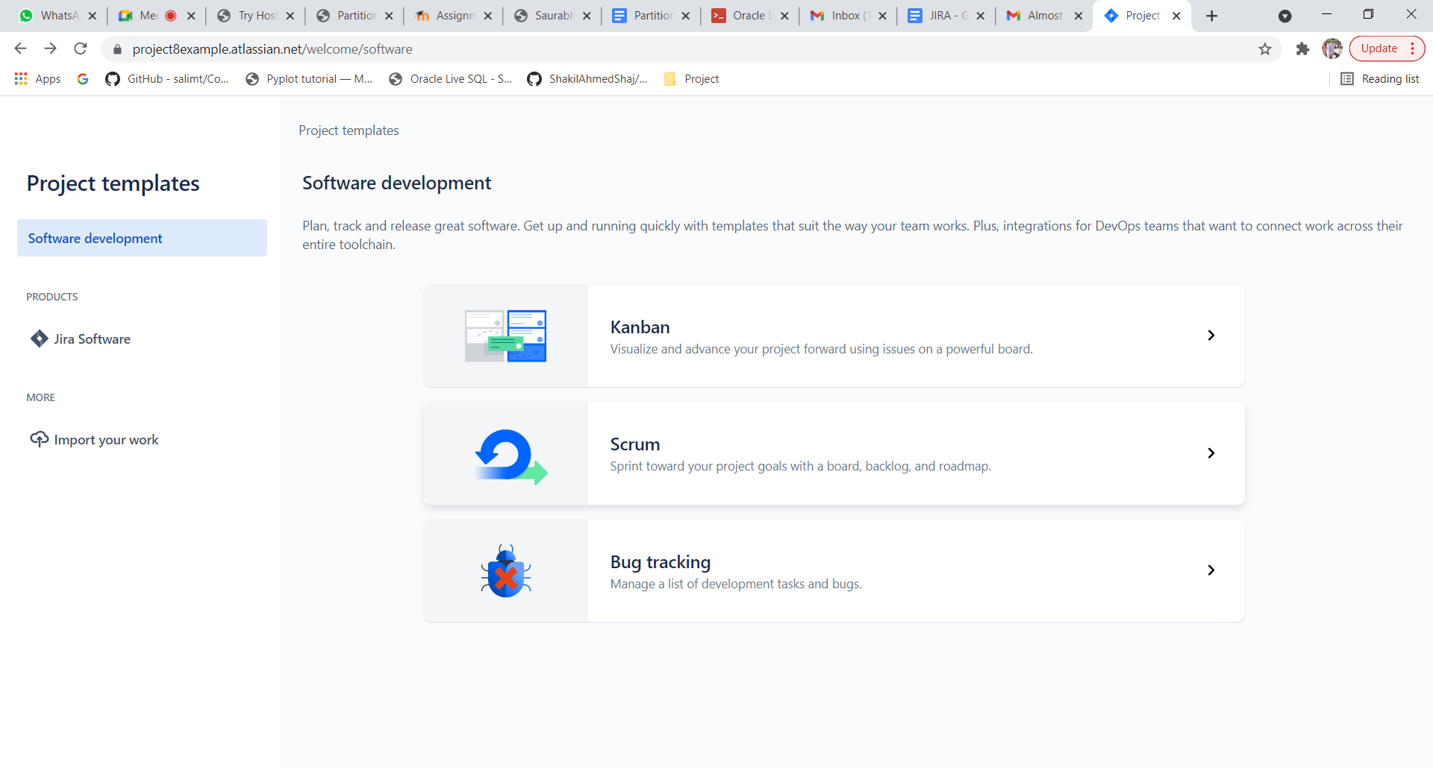

**Select Scrum Type and choose Use Template**

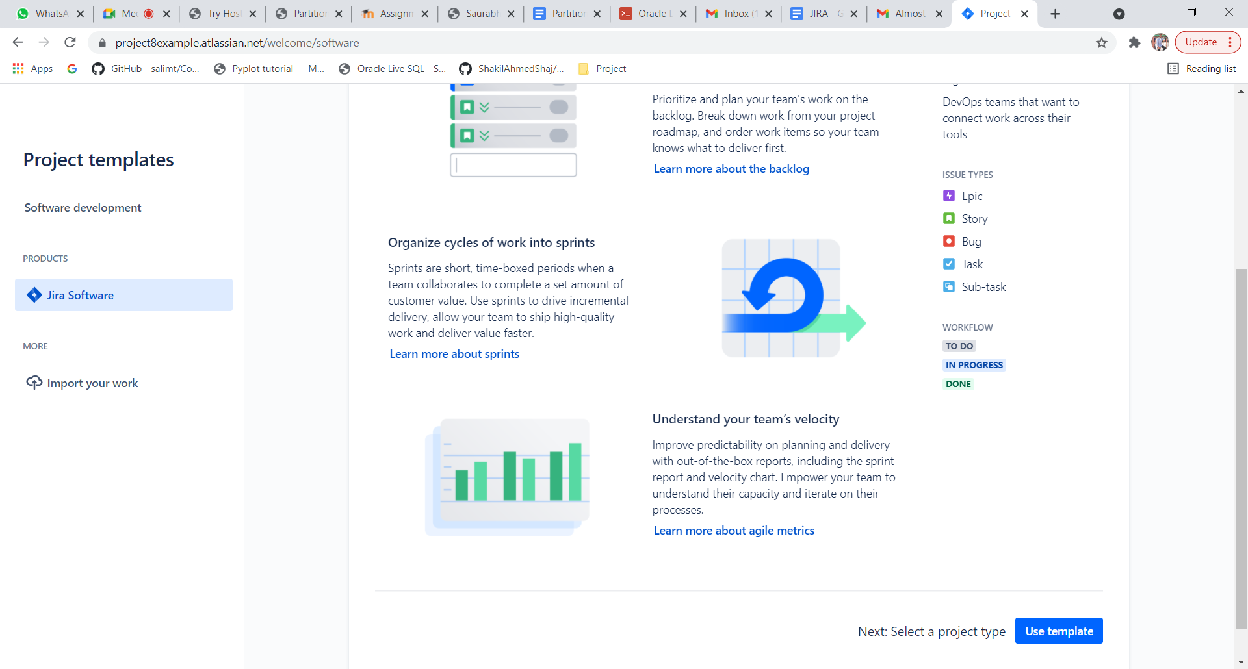

**Select Team Managed Project and Create Project , Name the Project .**

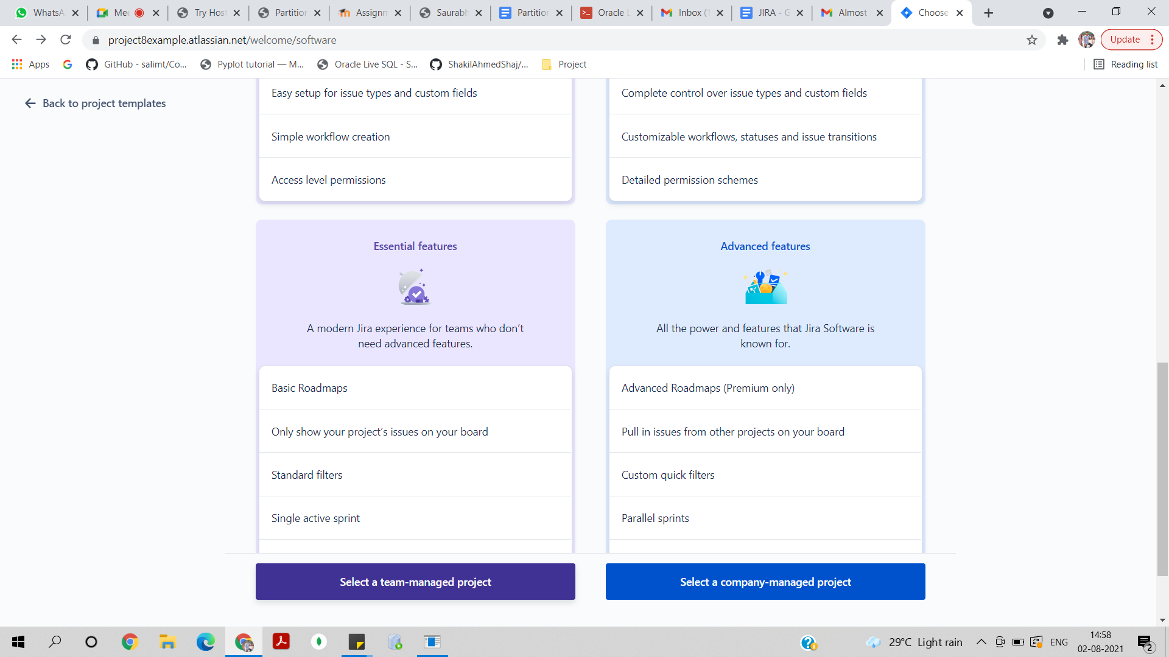

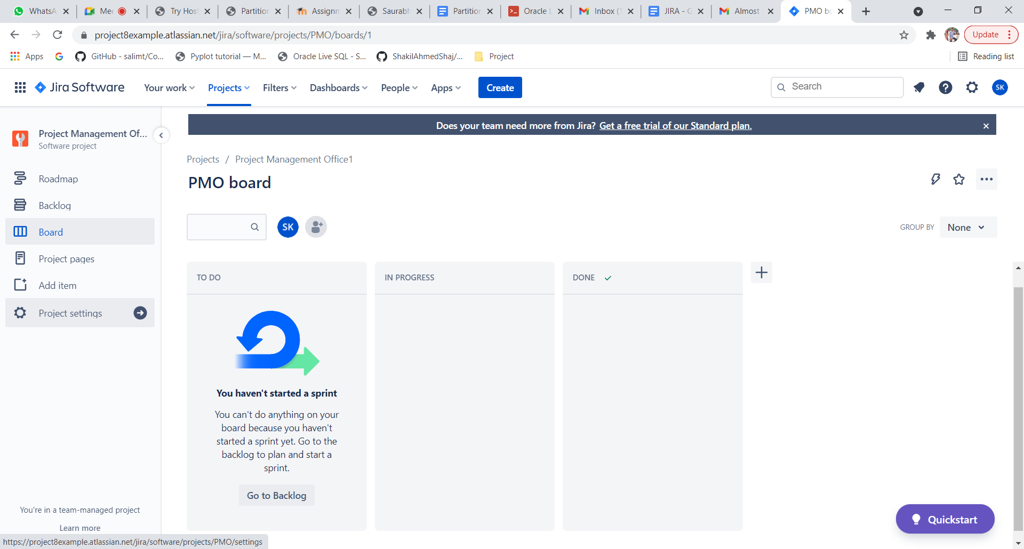

**Click on Add Item**

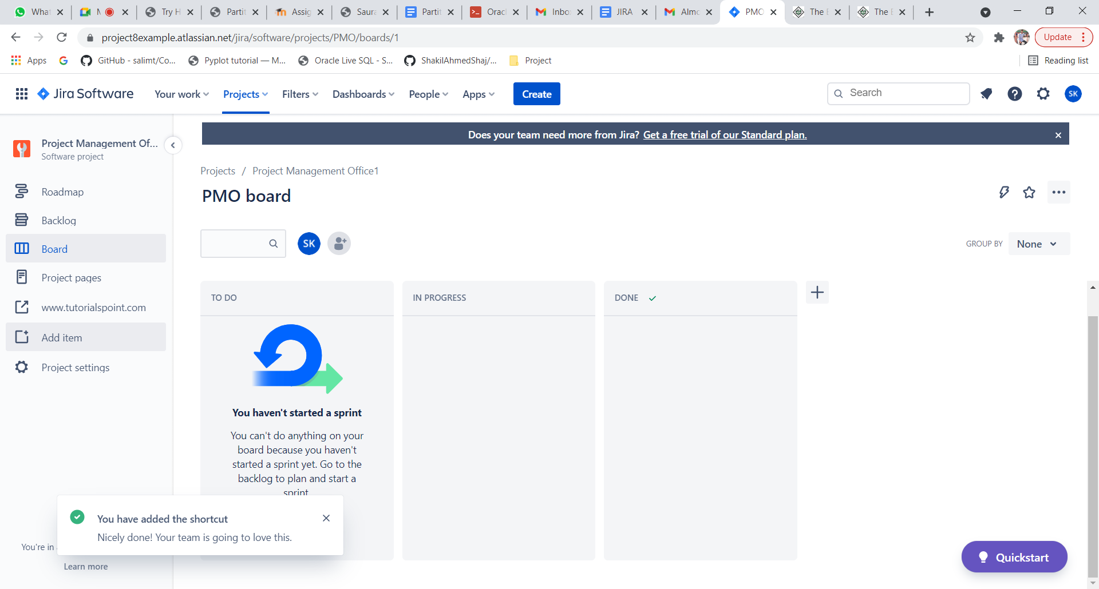

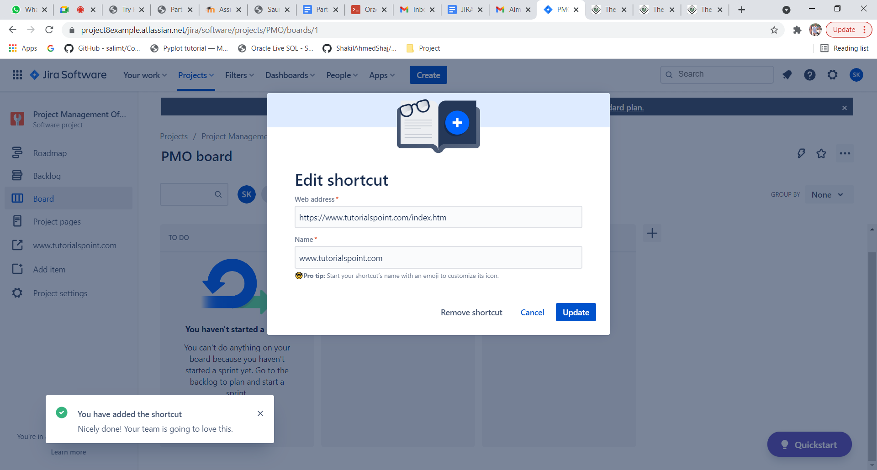

**Add People to the Project**

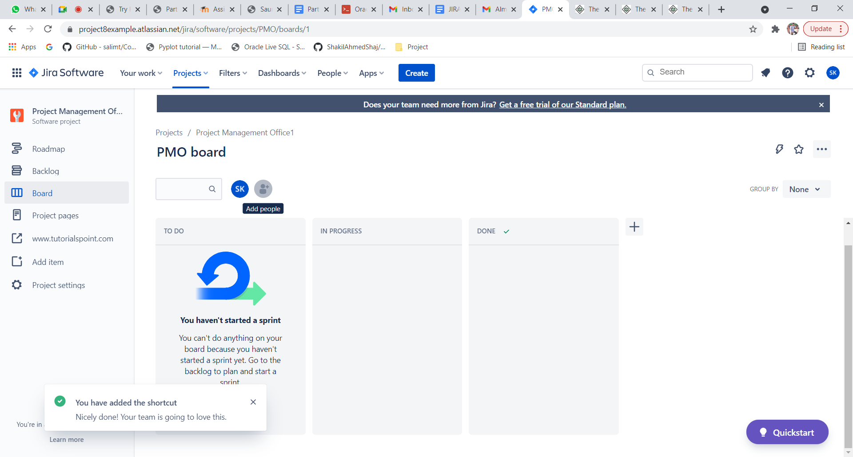

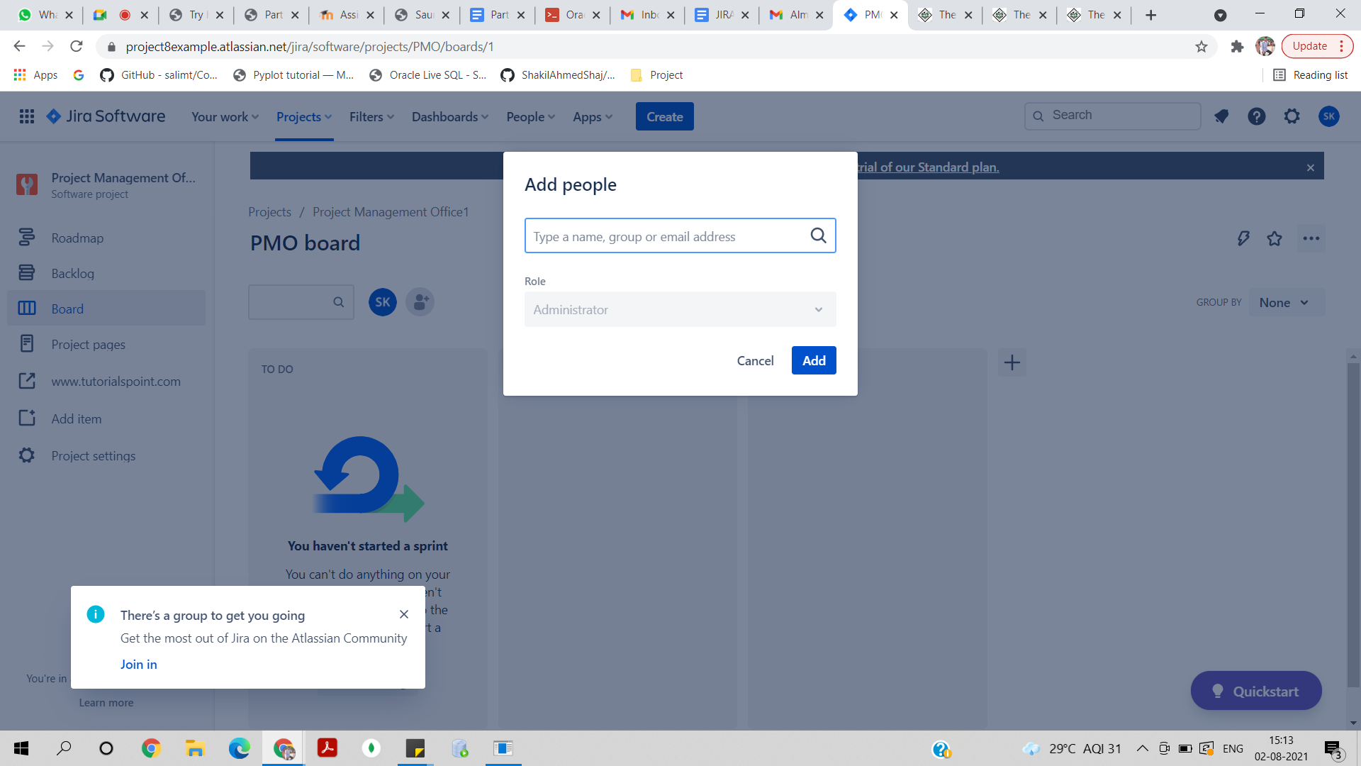

**Create Epic ,Click On Create**

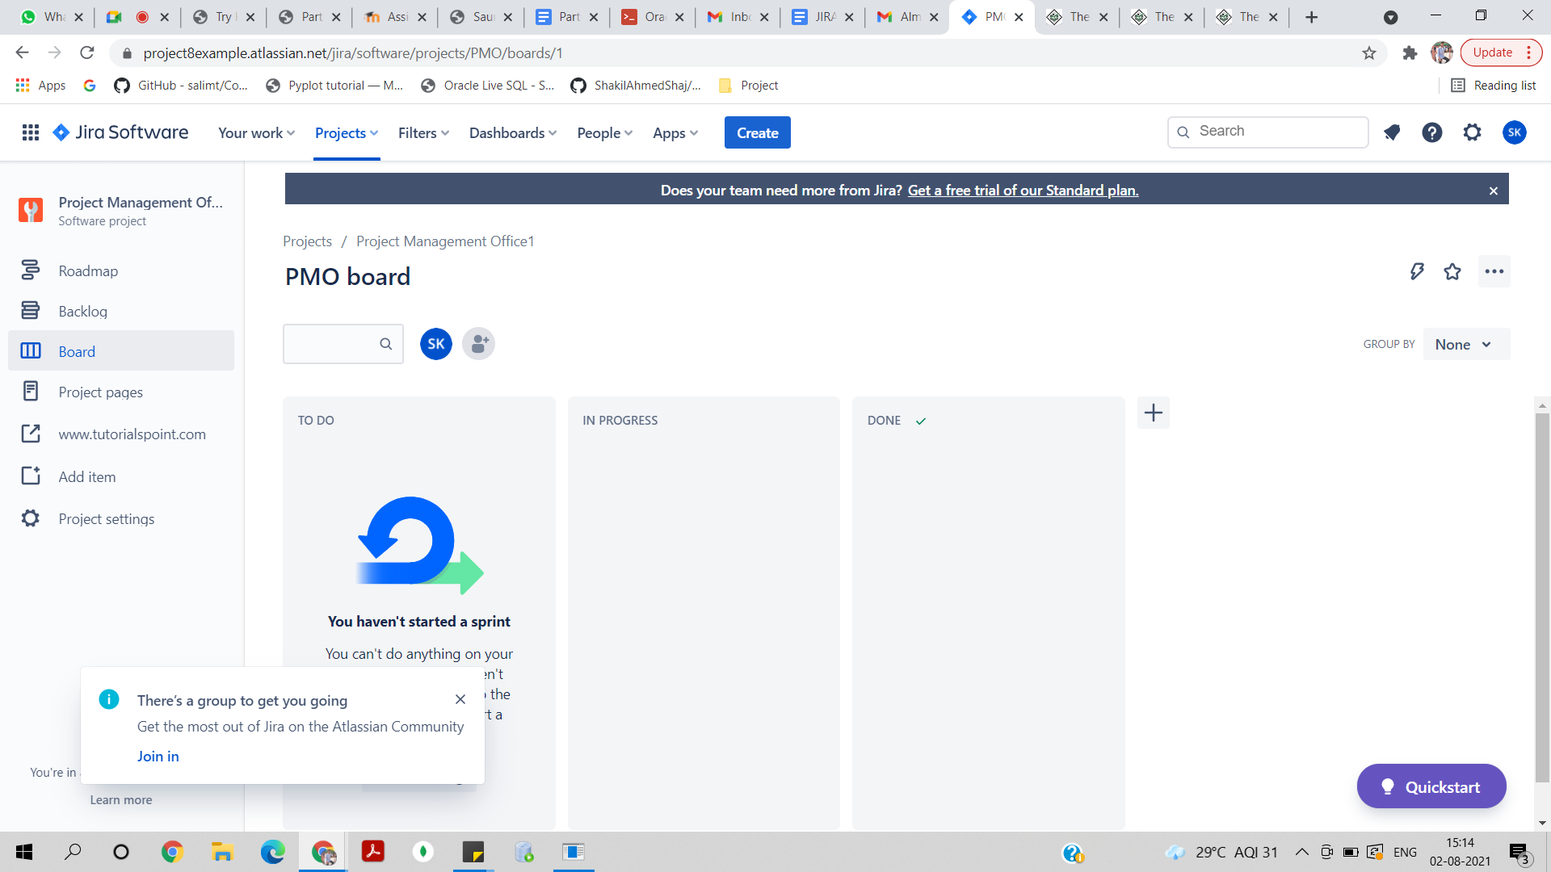

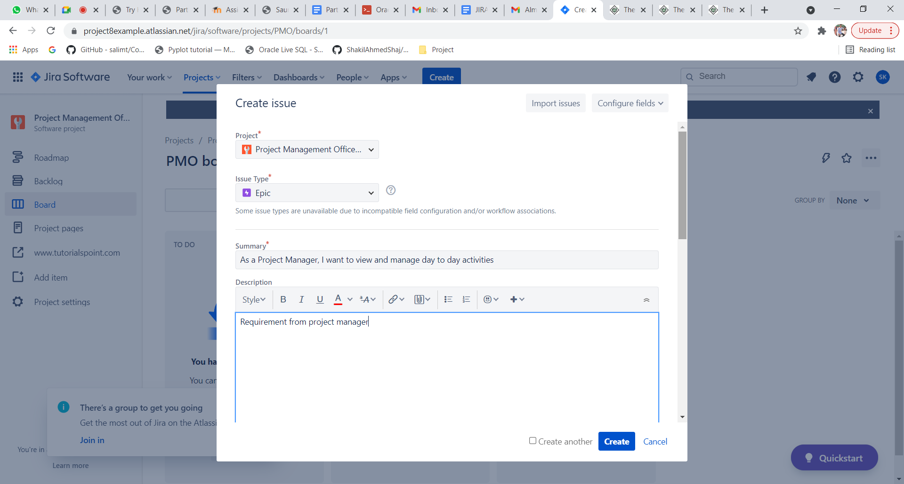

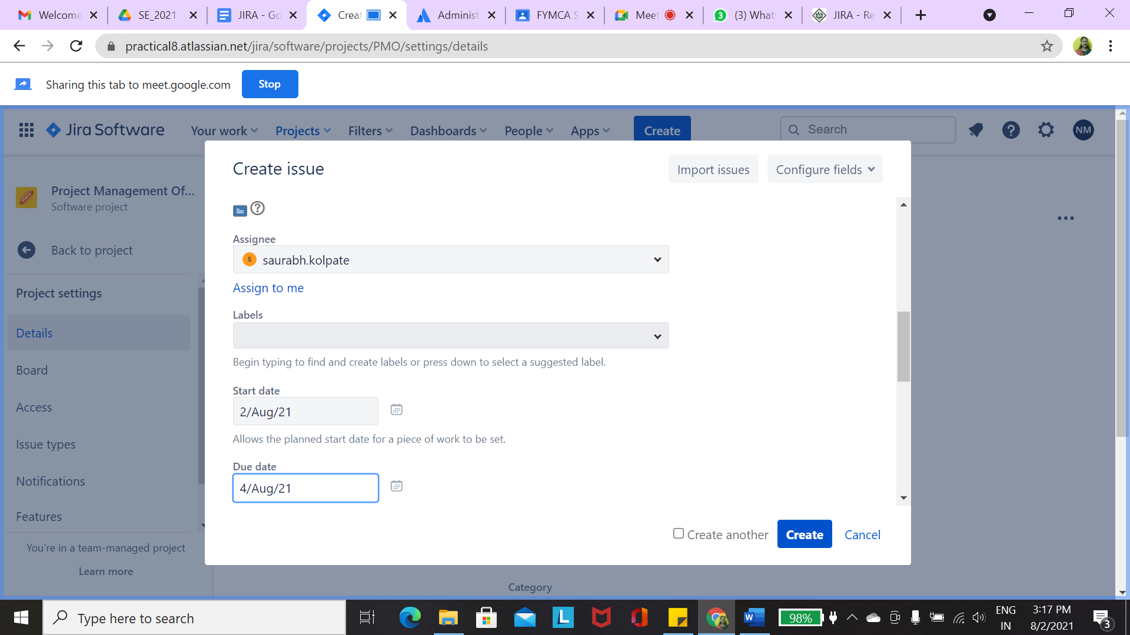

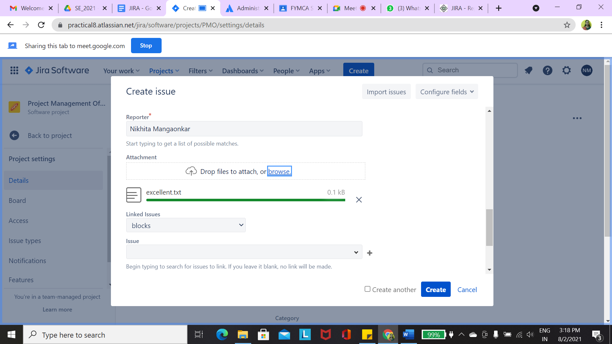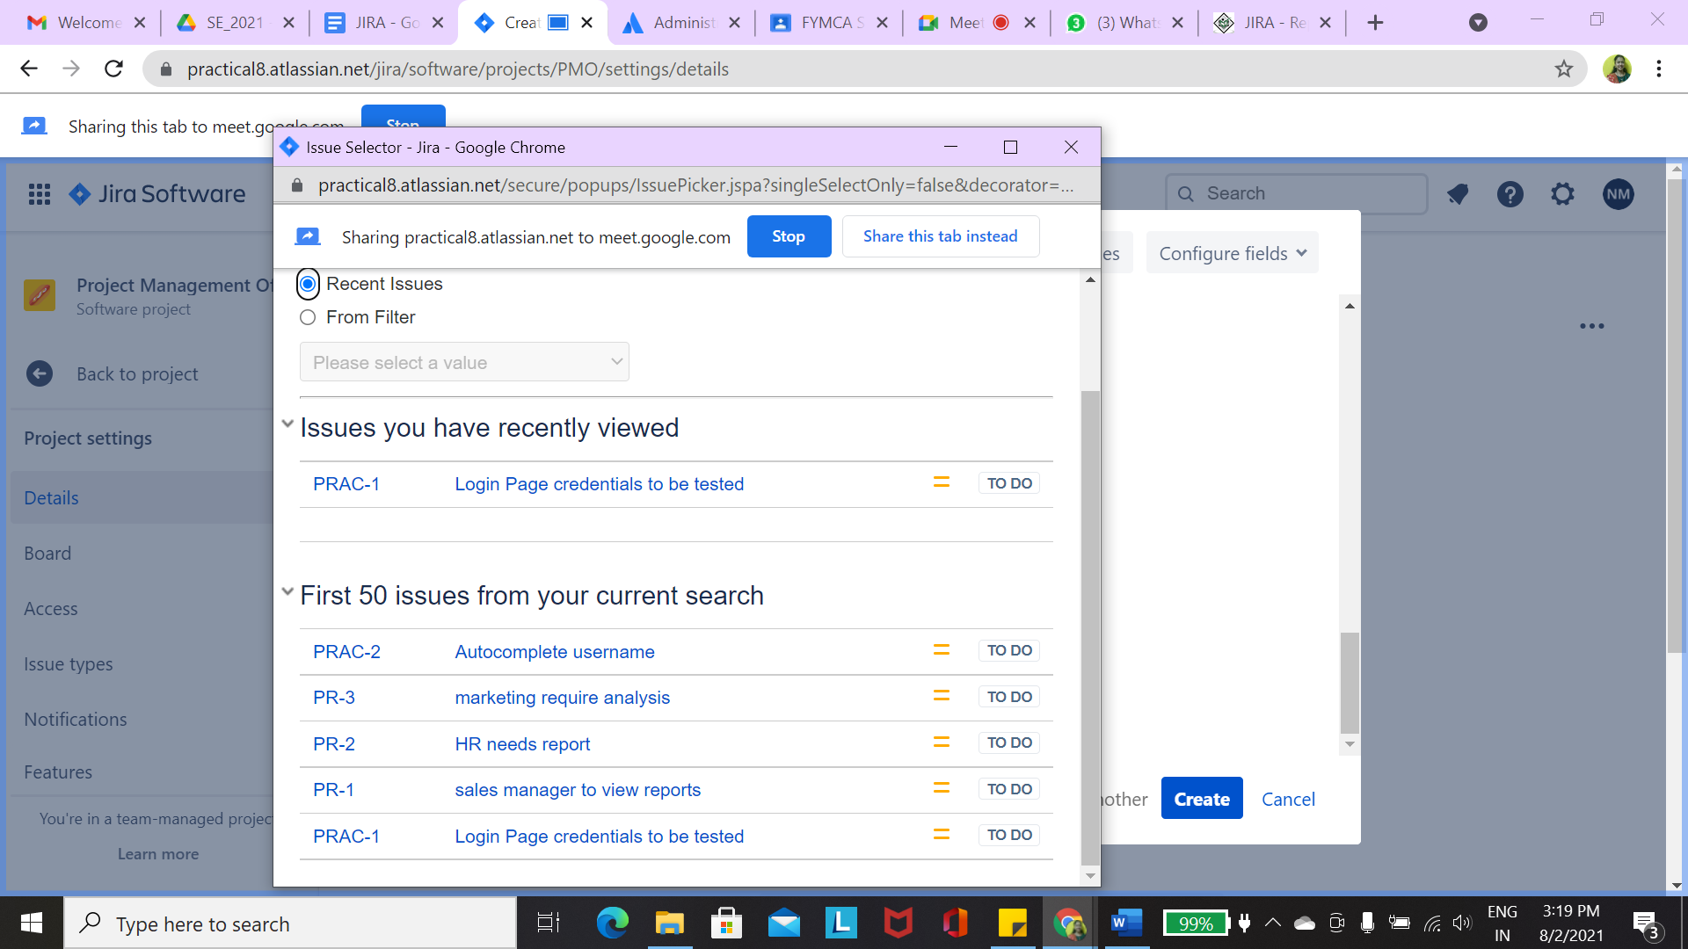

**Create User story**

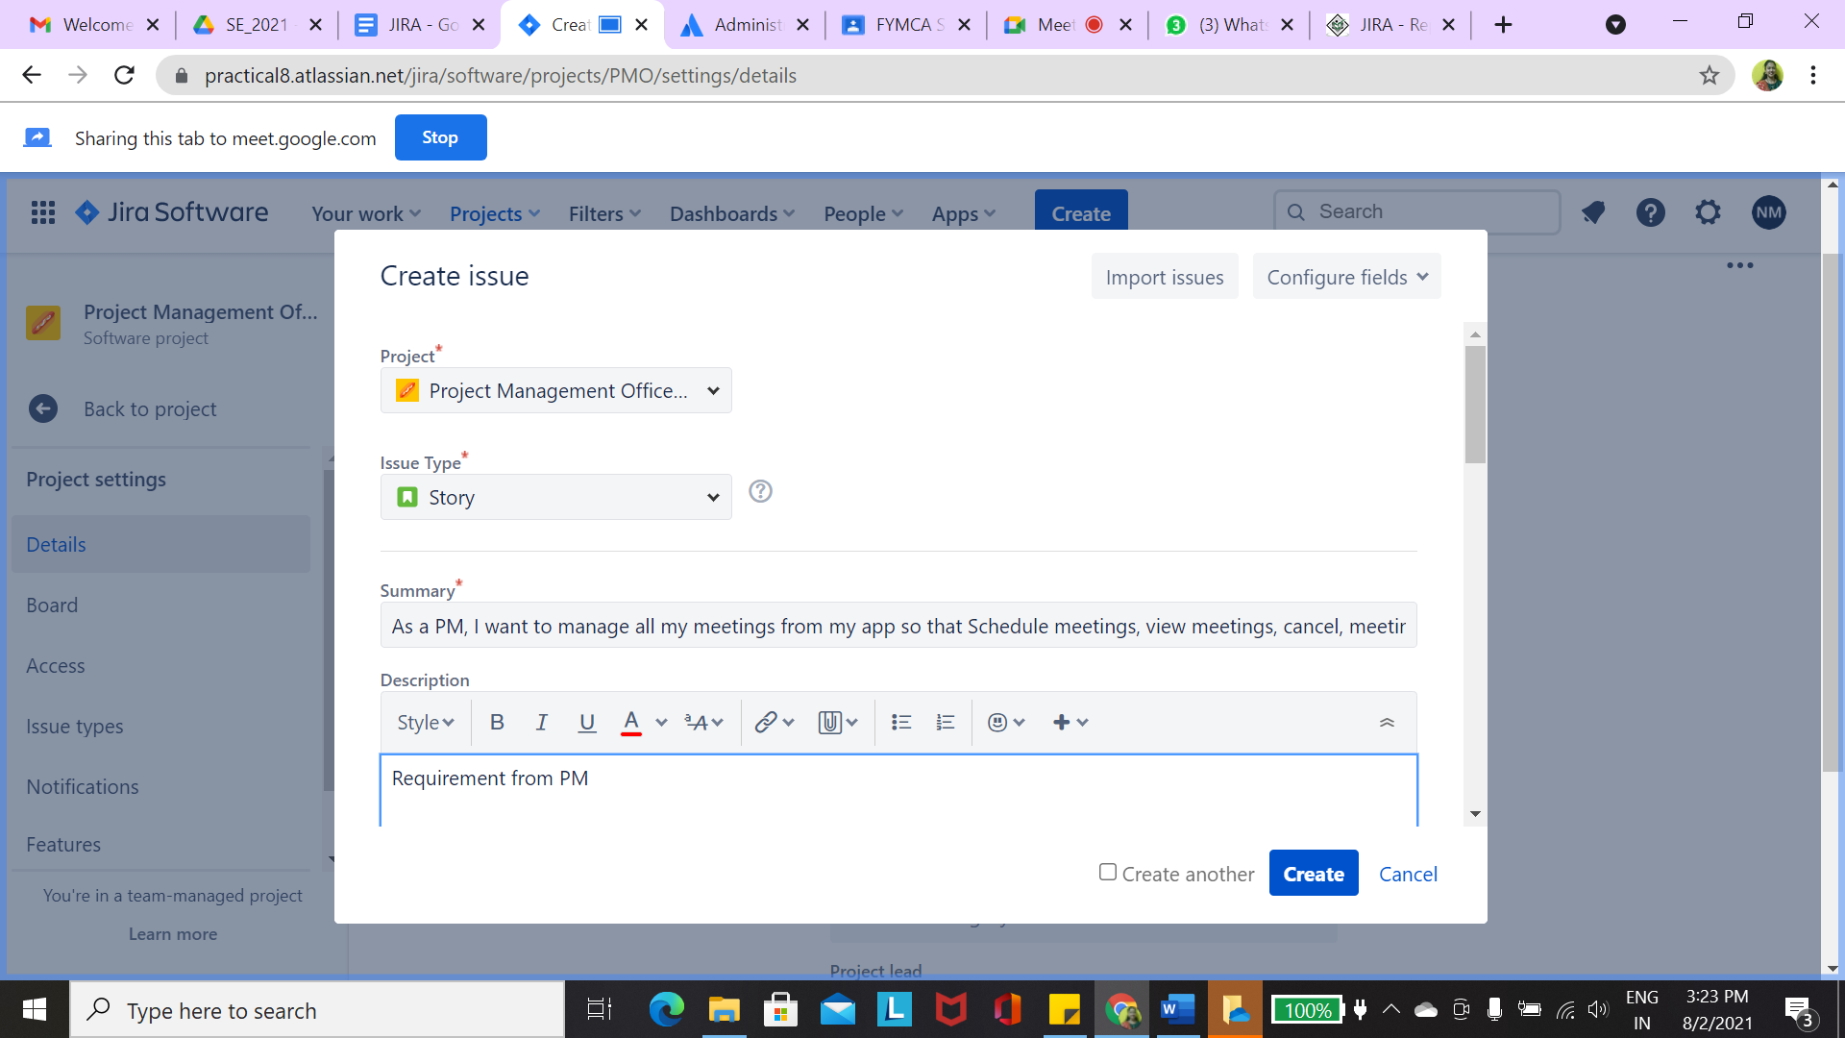

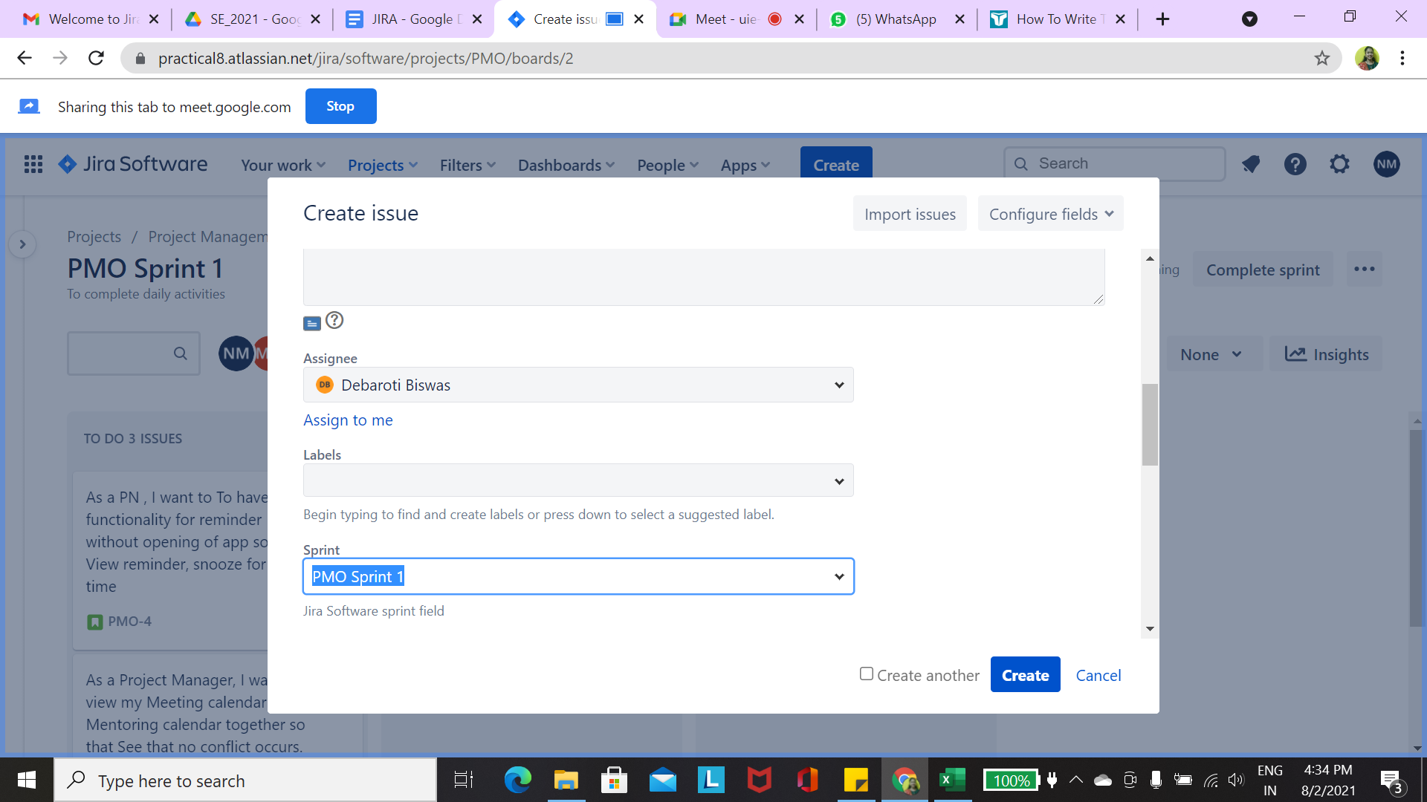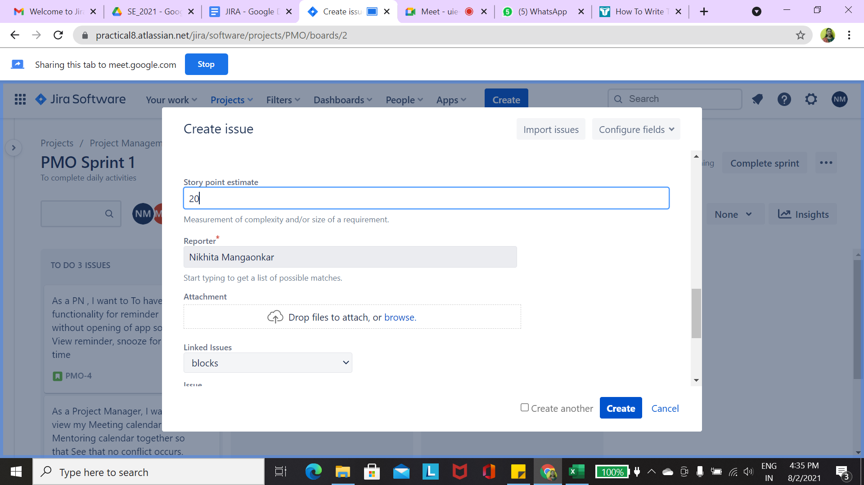

**Notifications to User (Mayur) -**

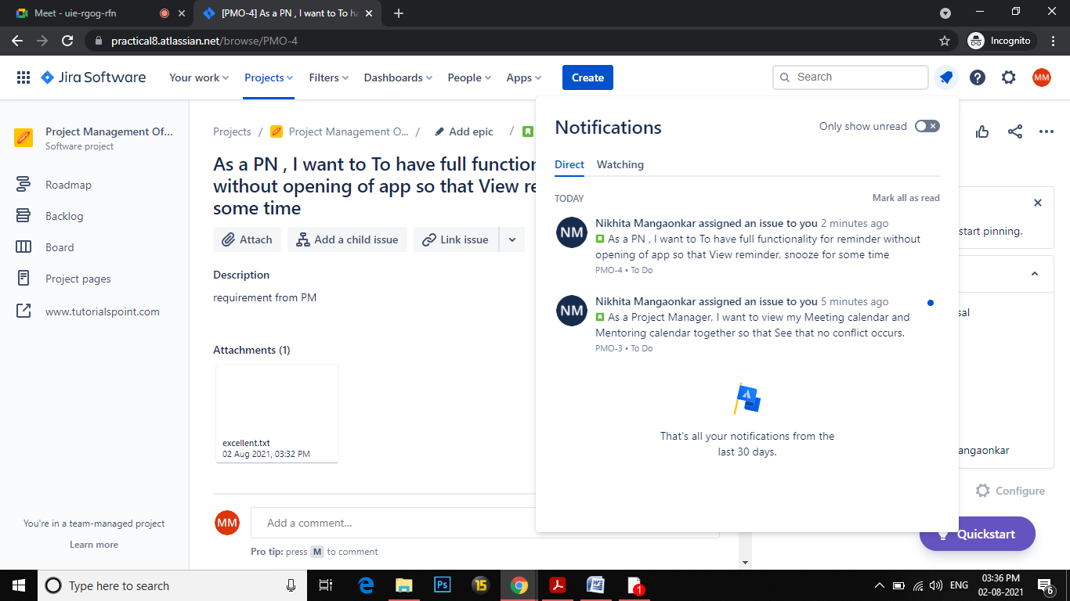

**Notifications to User (Saurabh) -**

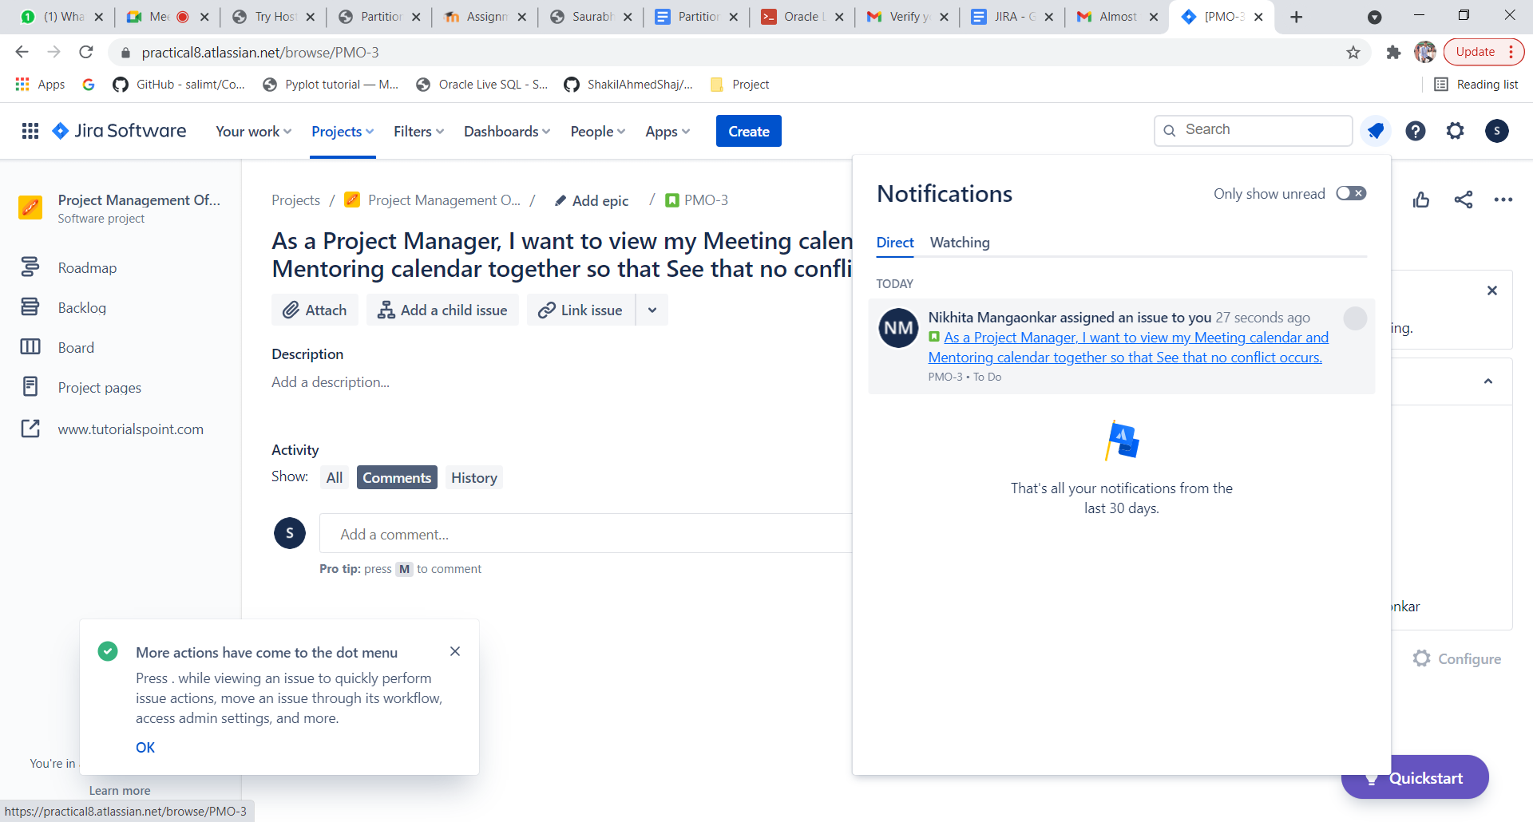

**Goto Backlog to create Sprints**

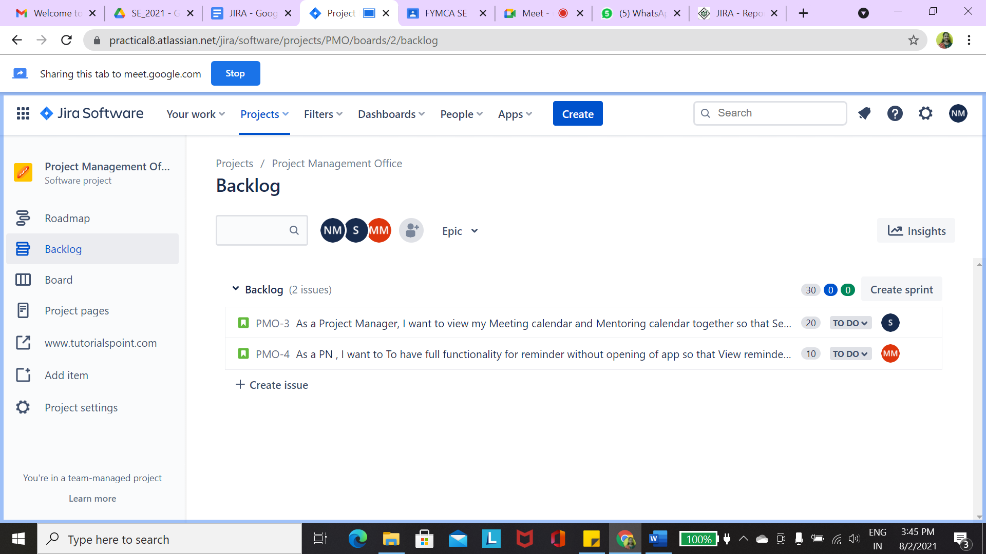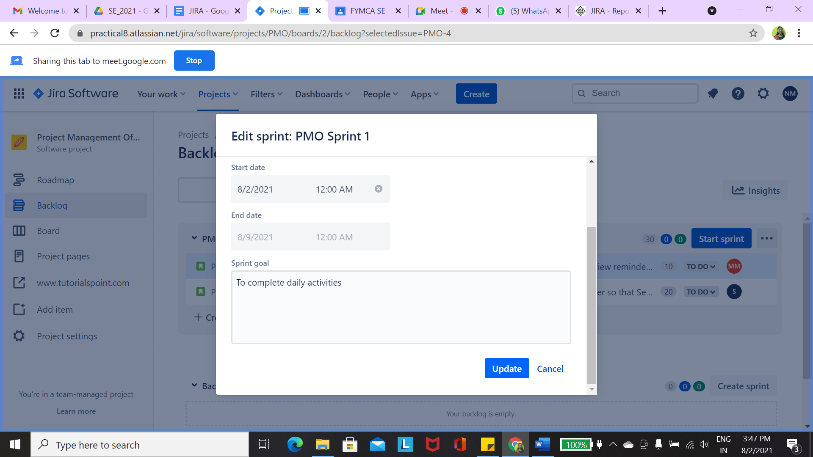

**Start sprint and view of Dashboard**

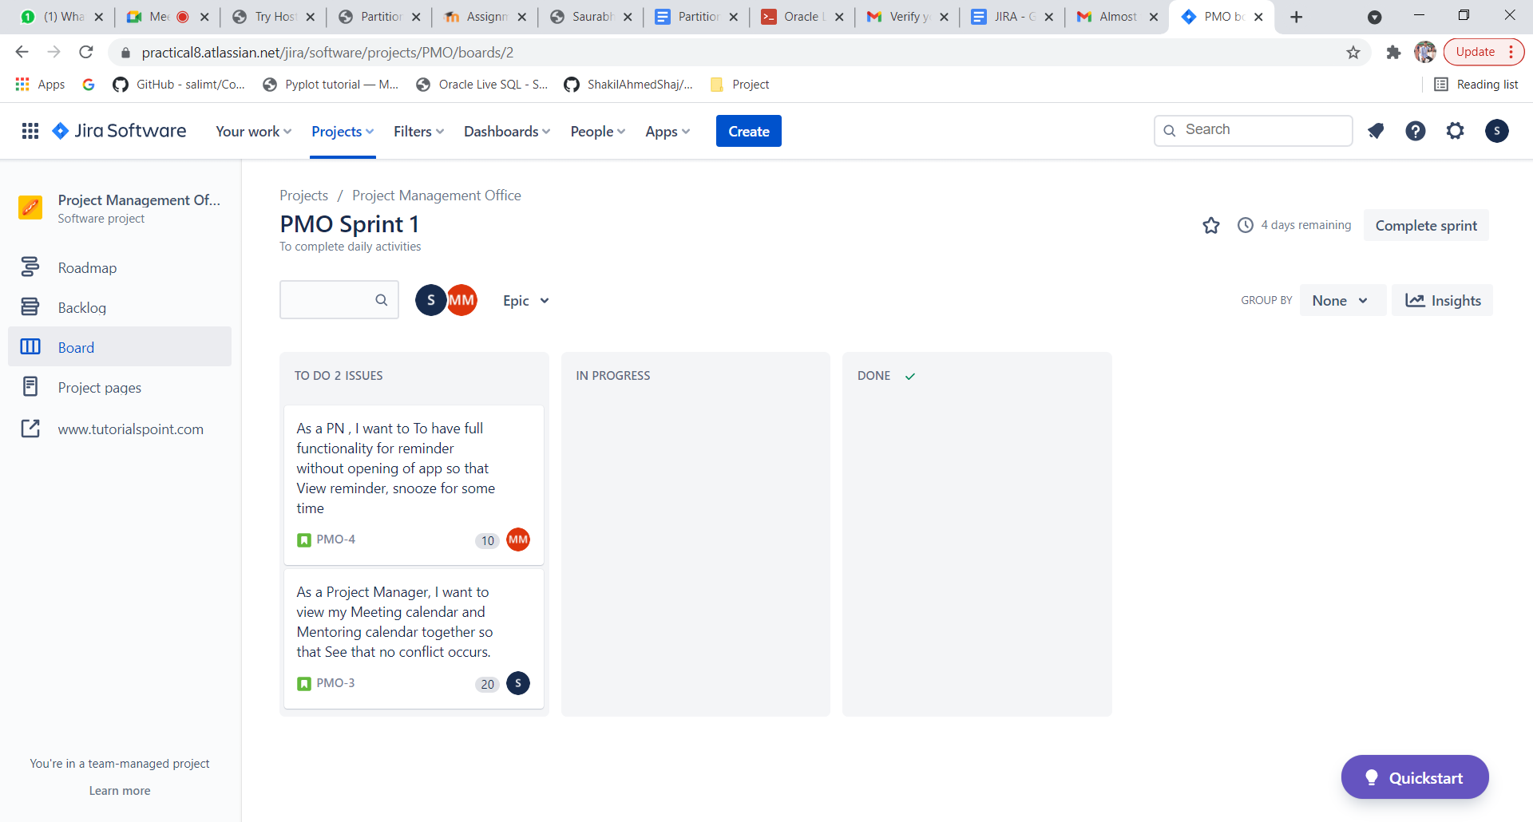

**Goto Project Settings > Features > Enable Reports - It appears in left panel Reports ( View Reports)**

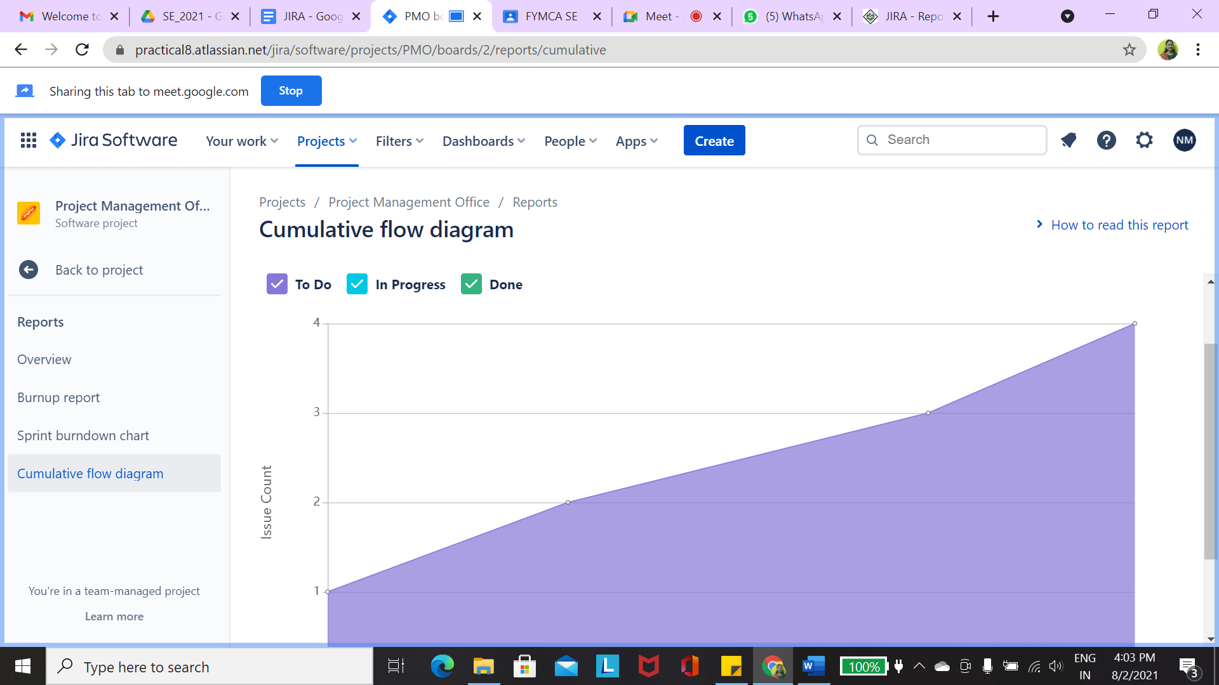

**Create Bug**

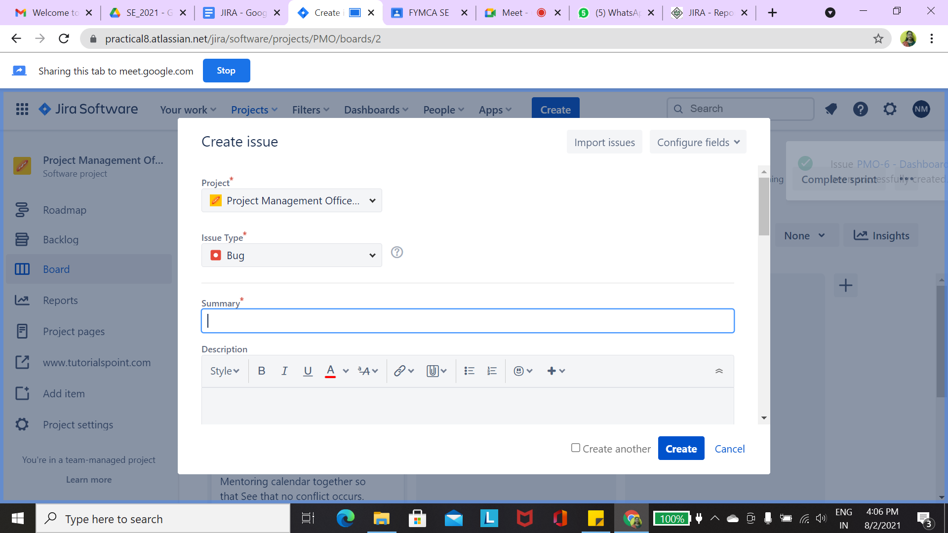

**TestPlan**

|  |  |  |  |  |  |
| --- | --- | --- | --- | --- | --- |
| **Test Id** | **Test Name** | **Test Description** | **Expected Output** | **Actual Output** | **Result** |
| **TC01** | **Login Credentials** | **Login with Valid Username invalid password** | **Login Unsuccessful, please enter correct credentials** | **Login Unsuccessful, please enter correct credentials** | **PASS** |
| **TC02** | **Login with invalid Username Valid password** | **Login Unsuccessful, please enter correct credentials** | **Login Successful** | **FAIL** |
| **TC03** | **Login with Valid Username and valid password** | **Login Successful** | **Login Successful** | **PASS** |

**Change Priority and Assignee change**

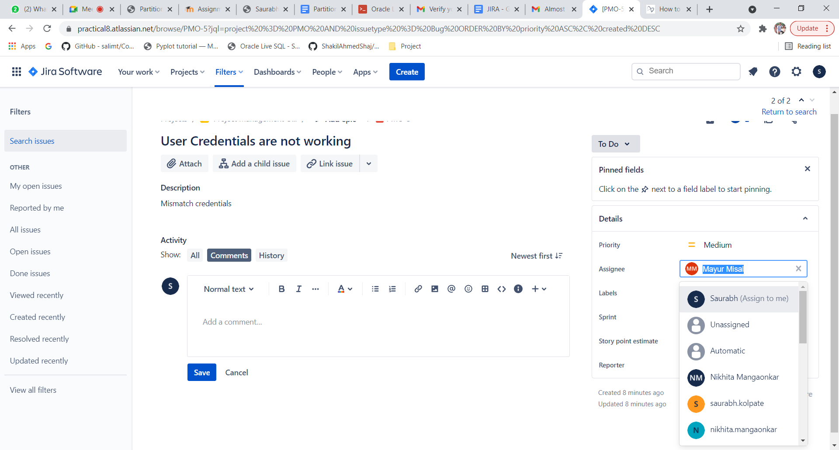

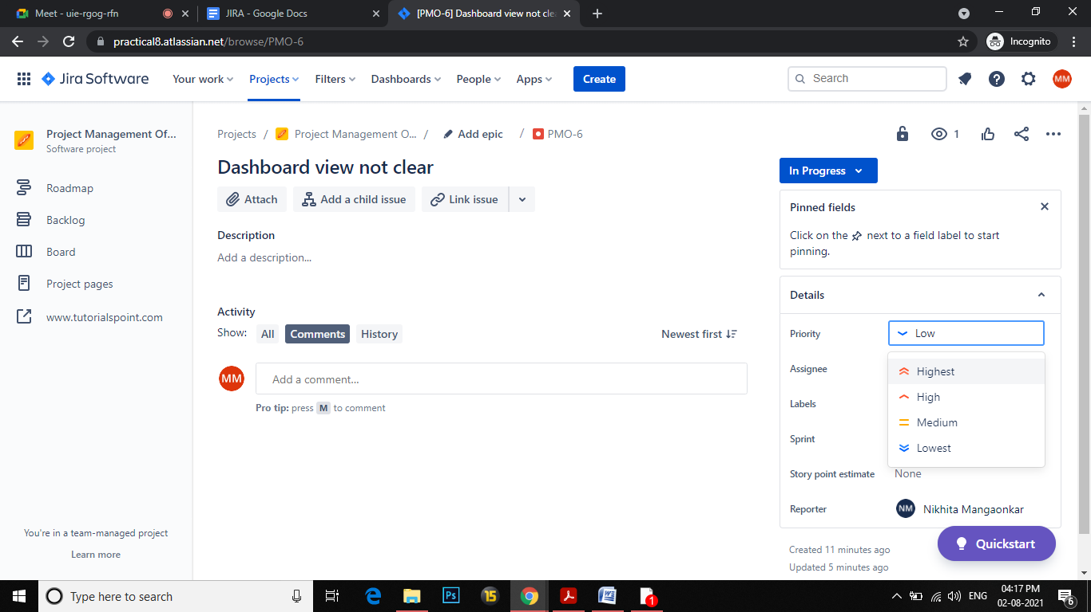

**Dashboard for Tracking Bug Issue .**

